**PLATE – 1**

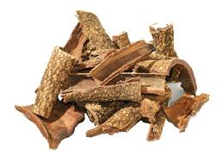

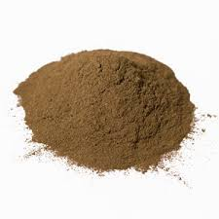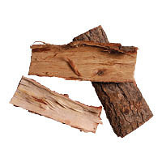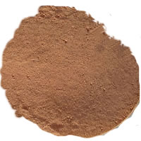

Fig. 1 b Photograph showing bark of Nimba

Fig. 1 d Photograph showing powder of bark of Nimba

Fig. 1 c Photograph showing powder of bark of Khadira

Fig. 1 a Photograph showing bark of Khadira