STUDY OF FC RECEPTOR-LIKE PROTEIN 3 AND ITS BINDING EFFICIENCY WITH HERBAL AND ALLOPATHIC ANTIBIOTICS
Sasikala P¹, Pugazhendy K*, Tamizhazhagan V¹, Sakthidasan V¹
¹Department of Zoology, Annamalai University, Tamilnadu, India.
Abstract
This present study aimed to determine the effect of drug (herbal and allopathic) on the FCRL3. FCRL3 protein sequence was collected from Uni-prot, protein sequence data base and submitted to the SIB- BLAST. The multiple sequence alignment was performed by comparing FCRL3. The protein sequence of Human was compared with domestic duck, Wild Yak, Black flying fox, American mink by using CLUSTAL W2. The secondary structure was determined by using CFSSP. The composition of amino acids was determined by using Protparam. The tertiary structure of FcRL 3 was predicted by using CPH modeling server and visualized through Rasmol. Ramachandran plot was performed for FCRL3 using Rampage software. The active sites were predicted by CASTp. The docking of FCRL3 with selected herbal Acetaminophen and Allopathic methimazole was performed by Hex 6.3.
Keywords: Graves’s disease, Herbal drug, Allopathic drugs, Acetaminophen, Methimazole.
INTRODUCTION
Bioinformatics is the field of science in which biology, computer science and information technology merges to form a single discipline. Bioinformatics has not only become essential for basic genomic and molecular biology research, but it's having a major impact on many areas of biotechnology and biomedical sciences. The areas of sequence analysis include sequence alignment, sequence database searching, motif and pattern discovery, gene and promoter finding, reconstruction of evolutionary relationships and genome assembly and comparison. Structural analyses include protein and nucleic acid structure analysis, comparison, classification and prediction. Functional analyses include gene expression profiling, protein-protein interaction prediction, protein subcellular localization prediction, metabolic pathway reconstruction and simulation [1]. Graves disease, named after is an autoimmune disease characterized by hyperthyroidism due to circulating autoantibodies[2]. Thyroid-stimulating immunoglobulins (TSIs) bind to and activate thyrotropin receptors, causing the thyroid gland to grow and the thyroid follicles to increase synthesis of thyroid hormone. Graves disease, along with Hashimoto thyroiditis, is classified as an autoimmune thyroid disorder. In some patients, Graves disease represents a part of more extensive autoimmune processes leading to dysfunction of multiple organs. Graves disease is associated with pernicious anemia, vitiligo, diabetes mellitus type 1, autoimmune adrenal insufficiency, systemic sclerosis, myasthenia graves, Sjögren syndrome, rheumatoid arthritis and systemic lupus erythematosus [3].
The signs and symptoms of Graves disease virtually all result from the direct and indirect effects of hyperthyroidism, with the main exceptions being Graves ophthalmopathy, goiter and proverbial myxedema. Symptoms of the resultant hyperthyroidism are mainly insomnia, hand tremor, hyperactivity, hair loss, excessive sweating, shaking hands, itching, heat intolerance, weight loss despite increased appetite, diarrhea, frequent defecation, palpitations, muscle weakness and skin warmth and moistness [4]. Further signs that may be seen on physical examination are most commonly a diffusely enlarged (usually symmetric), contender thyroid, lid lag, excessive lacrimation due to Graves ophthalmopathy, arrhythmias of the heart, such as sinus tachycardia, atrial fibrillation and premature ventricular contractions and hypertension [5]. People with hyperthyroidism may experience behavioral and personality changes including: psychosis, mania, anxiety, agitation and depression [6]. Since Graves disease is an autoimmune disease which appears suddenly, often quite late in life, a viral or bacterial infection may trigger antibodies which cross-react with the human TSH receptor. One possible culprit is the bacterium Yersinia enterocolitica. Although indirect evidence exists for the structural similarity between the bacteria and the human thyrotropin receptor, direct causative evidence is limited [7]. It is a common practice in Nigeria and other parts of the world to use the plant in the form of crude extracts, decoction, infusion or tincture to treat common infection and chronic conditions[8].
Yersinia seems not to be a major cause of this disease, although it may contribute to the development of thyroid autoimmunity arising for other reasons in genetically susceptible individuals [9]. It has also been suggested that Yersinia enterocolitica infection is not the cause of auto-immune thyroid disease, but rather is only an associated condition; with both having a shared inherited susceptibility [10]. More recently, the role for Yersinia enterocolitica has been disputed [11]. While theoretical mechanisms occur by which stress could cause an aggravation of the autoimmune response that leads to Graves disease, more robust clinical data are needed for a firm conclusion [12]. Differentiating two common forms of hyperthyroidism such as Graves’s disease and toxic multinodular goiter is important to determine the proper treatment. Measuring TSH-receptor antibodies with the h-TBII assay has been proven efficient and was the most practical approach found in one study [13]. Fibroblasts in the orbital tissues may express the thyroid stimulating hormone receptor (TSHr). This may explain why one autoantibody to the TSHr can cause disease in both the thyroid and the eyes [14]. Another effect of hyperthyroidism is bone loss from osteoporosis, caused by an increased excretion of calcium and phosphorus in the urine and stool. The effects can be minimized if the hyperthyroidism is treated early. Thyrotoxicosis can also augment calcium levels in the blood by as much as 25%. This can cause stomach upset, excessive urination, and impaired kidney function [15].
Less commonly, it has been known as Parry's disease, Begbie's disease, Flajani's disease, Flajani-Basedow syndrome and Marsh's disease [16]. These names for the disease were derived from Caleb Hillier Parry, James Begbie, Giuseppe Flajani and Henry Marsh. Early reports, not widely circulated, of cases of goiter with exophthalmos were published by the Italians Giuseppe Flajina and Antonio Giuseppe Testa, in 1802 and 1810, respectively [17]. Prior to these, Caleb Hillier Parry, a notable provincial physician in England of the late 18th century, described a case in 1786. This case was not published until 1825, but still 10 years ahead of Graves [18]. A recent update in this area showed a continuing incidence of 80 cases/100,000 women/year. Data attest to a lifelong incidence of autoimmune thyroid disease of > 6%, comprised roughly equally by Graves disease, Hashimoto`s thyroiditis and idiopathic hypothyroidism. Medicinal plants besides therapeutic agents are also a big source of information for a wide variety of chemical constituents[19].
It is a protein that in humans is encoded by the FCRL3 gene [20]. This gene encodes a member of the immunoglobulin receptor superfamily and is one of several Fc receptor-like glycoproteins clustered on the long arm of chromosome [21]. The encoded protein contains immunoreceptor-tyrosine activation motifs and immunoreceptor-tyrosine inhibitory motifs in its cytoplasmic domain and may play a role in regulation of the immune system. Mutations in this gene have been associated with rheumatoid arthritis, autoimmune thyroid disease and systemic lupus erythematosus [22]. Acetaminophen medications are available over the counter that ability to reduce swelling (inflammation) and pain. Anti-inflammatory products are effective in reducing joint and muscular pain and the associated swelling with Graves disease they are also excellent choices for arthritic pain and swelling. Acetaminophen is the most widely used over-the-counter medication in America. Most patients can safely use this medication for pain or fever. While not an effective anti-inflammatory medicine, many arthritic sufferers use acetaminophen to manage pain. Like all over-the-counter products, acetaminophen may present a health risk for some patients. Patients with liver disease, alcoholism or certain immune disorders should not use acetaminophen approval. Recently, acetaminophen use has been shown to be possibly hazardous to people having one or more alcoholic beverages daily. Methimazole ATD (antithyroid drugs) are used to help lower thyroid hormone levels in all can one recent Medline Update recommends ATD as the primary treatment for Graves disease. Common anti-thyroid drugs ATD include propylthiouracil PTU, methimazole and carbimazole. Carbimazole, which is primarily used outside of the United States, is essentially the same as methimazole. Of hyperthyroidism with the exception of thyroiditis. Methimazole is generally preferred over PTU since it has fewer side effects. However, because methimazole crosses the placental membrane more readily than PTU, PTU is recommended in pregnancy. In nursing mothers, a dose of 20mg or less of methimazole can be used[23, 24].
MATERIALS AND METHODS
The structure of FCRL3were predation with the help of bioinformatics tools and also docking with selected antibiotics such as herbal drug use of Drug bank (Acetaminophen) and allopathic The structure of FCRL3were predation with the help of bioinformatics tools and also docking drug use of (Methimazole) were analyzed [Table 1, Figure 2] Human FCRL3 Protein sequence was retrieved from the UNI-PROT protein sequence database. By use of CFSSP the secondary structure was determined. The tertiary structure of FCRL3 was predicted by using CPU3.2 sever and visualized using RasMol. The Ramachandran plot was performed for FCRL3 by using Rampage software. CASTp predicted the active sites.
UNI PROT
The UniProt consortium comprises the European Bioinformatics Institute (EBI), the Swiss Institute of Bioinformatics (SIB) and the Protein Information Resource (PIR). EBI, located at the Wellcome Trust Genome Campus in Hinxton, UK, hosts a large resource of bioinformatics databases and services. SIB, located in Geneva, Switzerland, maintains the ExPASy servers that are a central resource for proteomics tools and databases [25]. Margaret Dayhoff's Atlas of Protein Sequence and Structure first published in 1965. In 2002, EBI, SIB and PIR joined forces as the UniProt consortium [26]. Fc receptor-like protein3 was selected as the candidate for the present study the whole complete protein sequence is available. The protein sequence of Fc receptor-like protein3 was collected from Uni –Prot protein sequence database.
FASTA
FASTA is a DNA and protein sequence alignment software package. Its legacy is the FASTA format which is now ubiquitous in bioinformatics. FASTA added the ability to do with DNA: DNA searches, translated protein: DNA searches and also provided a more sophisticated shuffling program for evaluating statistical significance [27].
BLAST
In bioinformatics, BLAST for Basic Local Alignment Search Tool is an algorithm for comparing primary biological sequence information, such as the amino-acid sequences of different proteins or the nucleotides of DNA sequences. BLAST [28] and ORIS algorithms. Results of KLAST are very similar to BLAST, but KLAST is significantly faster and capable of comparing large sets of sequences with a small memory footprint.
CLSTAL W2
ClustalW2 is a fully automatic program for global multiple alignment of DNA or protein sequences [29]. The alignment is progressive and considers sequence redundancy.
PROTPARAM
There are different tools available through ExPasy server to analyze a protein sequence ExPASy.
CFSSP
The Chou–Fasman method is an empirical technique for the prediction of secondary structures in proteins, originally developed in the 1970s by Peter [30]. From these frequencies a set of probability parameters were derived for the appearance of each amino acid in each secondary structure type and these parameters are used to predict the probability that a given sequence of amino acids would form a helix, a beta strand, or a turn in a protein [31]. Is SIB Bioinformatics Resource Portal the method is at most about 50–60% accurate in identifying correct secondary structures, which are significantly less accurate than the modern machine learning–based techniques [32].
CPH MODELS
CPH models 3.2 are a protein homology-modeling server. Template recognition is based on profile-profile alignment guided by tertiary structure and exposure predictions.
RASMOL
RasMol is a computer program written for molecular graphics visualization intended and used primarily for the depiction and exploration of biological macromolecule structures, such as those found in the Protein Data Bank. It was originally developed by Roger Sayle in the early 90s. RasMol has a complex version history. Starting with the series of 2.7 versions Rasmol is licensed under a dual license. RasMol includes a language [33].

RAMACHANDRAN PLOT
Ramachandran plot (also known as Ramachandran diagram or a [φ, ψ] plot), originally developed in 1963 [34]. It is a way to visualize backbone dihedral angles. Ψ against φ of amino acid residues in the protein structure. The figure at left illustrates the definition of the φ and ψ backbone dihedral angles (called φ and φ' by Ramachandran). The ω angle at the peptide bond is normally 180, since the partial-double-bond character keeps the peptide planar .
CASTp
Computer Atlas of Surface Topology of Proteins CASTp ) , is a tool in Bioinformatics which is an online resource for identifying some of the geometric properties of protein like locating, delineating and measuring concave surface regions on 3D structures of proteins obtained from PDB also to study surface features, functional regions and active site of proteins. As this tool helps in finding cavity or pockets in the structure, it is used for identifying active sites where drugs can be bind.
DRUG BANK
The Drug Bank database is a comprehensive, high-quality, freely accessible, online database containing information on drugs and drug targets [35]. As both a bioinformatics and a cheminformatics resource, Drug Bank combines detailed drug (i.e. Chemical, pharmacological and pharmaceutical) data with comprehensive drug target (i.e. Sequence, structure and pathway) information. Because of its broad scope, comprehensive referencing and unusually detailed data descriptions, Drug Bank is more akin to a drug encyclopedia than a drug database maintained for Drug Bank is widely used by the drug industry, medicinal chemists, pharmacists, physicians, students and the general public. Its extensive drug and drug-target data has enabled the discovery and rephrasing of a number of existing drugs to treat rare and newly identified illnesses. Each Drug Card entry contains more than 200 data fields with half of the information being devoted to drug chemical data and the other half devoted to drug target or protein data [35].
HEX 6.3
Hex was written by Dave Ritchie of the University of Aberdeen [36]. Hex is an interactive molecular graphics program for calculating and displaying feasible docking modes of pairs of protein and DNA molecules. Hex can also calculate protein-ligand docking, assuming the ligand, is rigid and can superpose pairs of molecules using only knowledge of their 3D shapes.
RESULTS
In the present study, the structures of Fc Receptor-like protein3 (FCRL) were predicted with the help of Bioinformatics tools and also docking with selected antibiotic such as herbal drug (Acetaminophen) and allopathic drug (Methimazole) was analyzed. Human Fc Receptor-like protein3 sequence was retrieved from the UNI-PORT protein sequence database and submitted to the SIB-, BLAST. The multiple sequence alignment was performed by comparing (Table 1) Fc receptor-like protein3. The protein sequence of Human was compared with domestic duck, Wild Yak, Black flying fox, American mink by using CLUSTAL W2. From the result, it was observed that Fc receptor-like protein3 of Wild Yak and Human are closely related. Likewise Fc receptor-like protein3 of Black flying fox, Domestic duck, and American mink is closely related to each other. Fc receptor-like protein3 of Black flying fox, is more distantly related to human Fc receptor-like protein3. Amino acid composition was determined for the human Fc receptor-like protein3. Fc receptor-like protein3 has 734 amino acids with the molecular weight of 80856.1. Its theoretical PI is 6.56. Aliphatic amino acids serine is present in highest number (82). Further the amino acids Alanine, Glutamic, Glycine, Lucien, Serine, Threonine and Valine are also higher number for 45, 45, 29 and 28 respectively. The negatively charged amino acid aspartic is lesser than the glutamate acid. The positively charged amino acid arginine is lesser than the Serine. It has the estimated half-life of 30 hours. Its instability index is 46.16 and its aliphatic index is 85.40. It has the grand average of hydropathy city. Fc receptor-like protein3 has 11295 atoms. Among them the carbon, hydrogen, nitrogen, oxygen and sulphur atoms are present in 3556, 5603, 1019, 1095 and 22 numbers respectively. The secondary structure (Figure 2) of Fc receptor-like protein3 has 402% alpha helix, 103% extended strand, 34.8% beta turns and 38. 1% random coil. The Ramachandran plot showed that Fc receptor-like protein has 225amino acids (87.5%) are in a favored region 23(8.9%) are allowed region and 9 (3.4%) are in outlier region. This proves that the predicted model is acceptable. CASTp predicated the actives sites. Fc receptor-like protein3 structure has 38 active sites. Fc receptor-like protein3 has four large active sites (35, 36, 37, 38) and one small active site (9). Docking (Figure 3 and 4) of Fc receptor-like protein3 with selected 1 herbal antibiotic (ACETAMINOPHEN) and 1 allopathic antibiotic (METHIMAZOLE) were performed by the use of the Tool Hex 6.3.

Table 1. Herbal drug and Allopathic drug docking in Graves’s disease FCRL3
Herbal drug
Ligand | E.TOTAL | E.SHAPE | E.FORCE | BUMPS | RMS
Acetaminopen | -119.86 | -119.86 | 0.00 | -1 | -1.00
Allopathic drugs
Ligand | E.TOTAL | E.SHAPE | E.FORCE | BUMPS | RMS
Methimazole | -101.42 | -101.42 | -0.00 | -1 | -1.00

Figure 1. Herbal drug acetaminophen-chemical structure
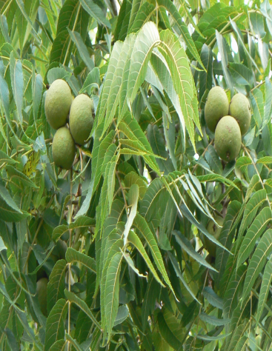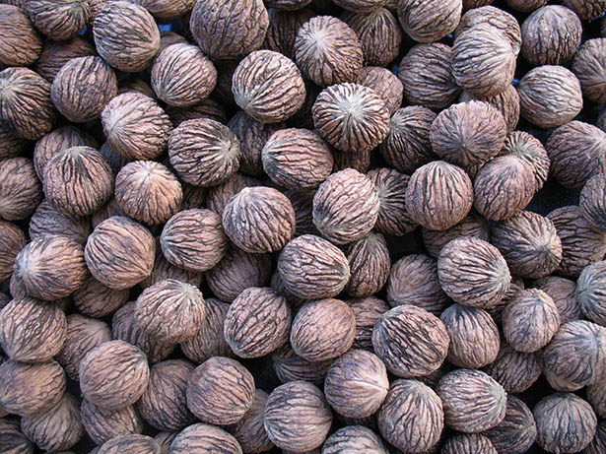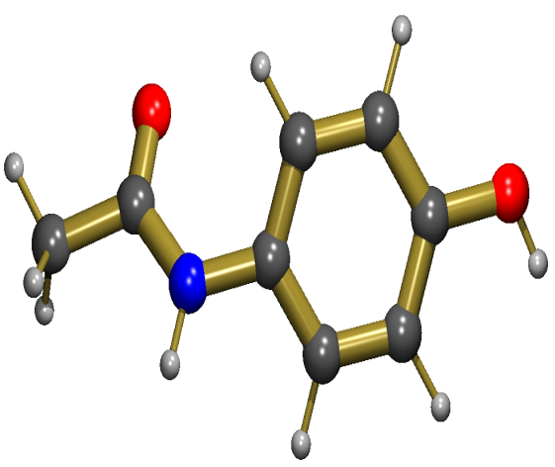

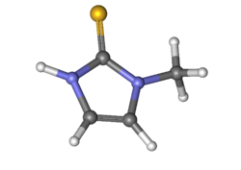
Figure 2. Allopathic drug methimazole-chemical structure

Figure 3. Herbal drug docking Graves disease FCRL3 with Acetaminophen
- Before Docking b) After Docking
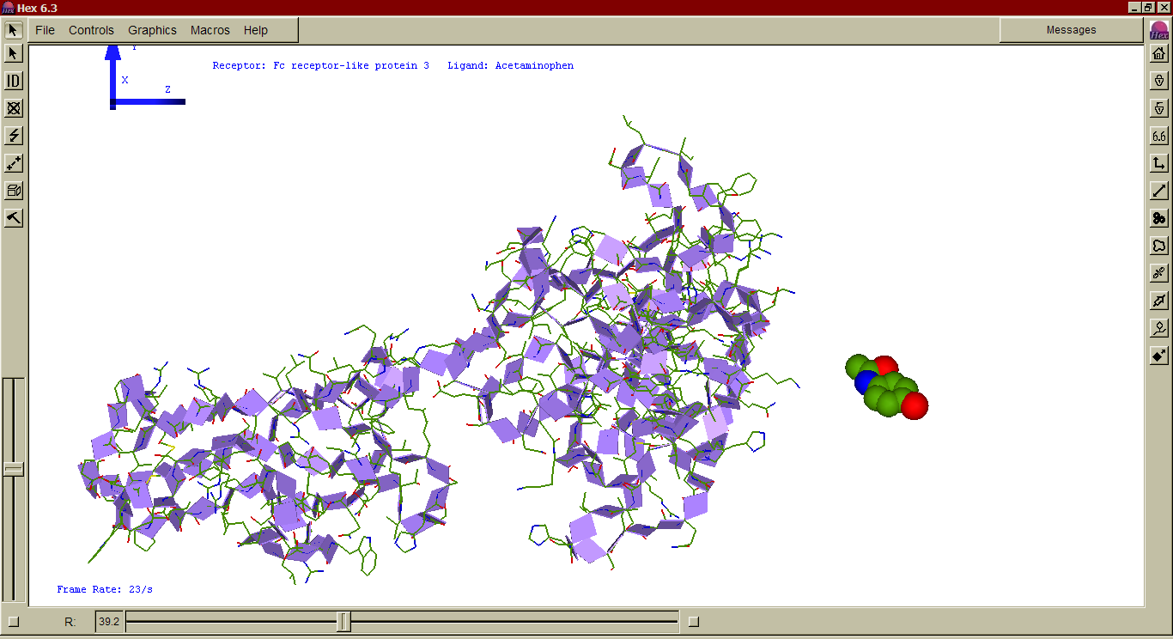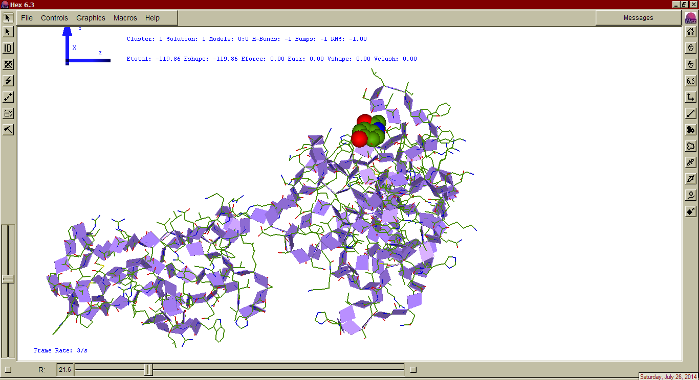

Figure 4. Allopathic drug docking Graves disease FCRL3 with Methimazole
- Before Docking b) After Docking
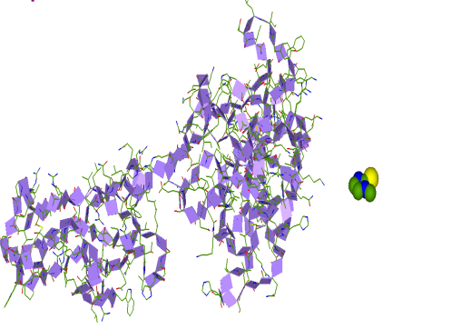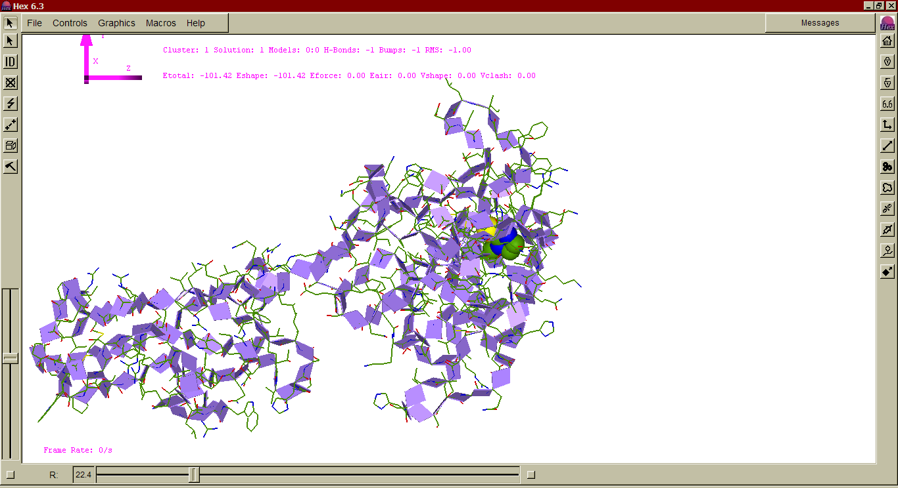
Discussion
Asia has abundant species of medicinal and aromatic plants and traditional medicines have practiced in Asia since ancient times. India has made use of medicinal plants to cure ailments of thousands of years[37] The Fc receptor-like protein3 sequence was collected from the UNI-PROT Performed BLAST for sequence retrieval. The multiple sequence alignment was performed by comparing the Fc receptor-like protein3 sequence of Homo Sapiens, Anas platyrhynchos Bos mutters, Pteropus alecto and Neovisn vision by using CLUSTA W2. Fc receptor-like protein3 Ceta of Human are closely related. Like wise Fc receptor-like protein3 of Pteal, Anapl and Neovi closely related to each other. Pteal, is distantly related to human Fc receptor-like protein3. By use of CFSSP the secondary structure was determined. Fc receptor-like protein3 has 402% alpha helix and 34.8% beta turns. Performed PROTPRAM to determine the number and composition of amino acids. Fc receptor-like protein3 has 734 amino acids. Serine is present in the highest number. The tertiary structure of Fc receptor-like protein3 was predicated by using CPH Models 3.2 servers and visualized using RASMOL. The Ramachandran plot was performed for Fc receptor-like protein3 by using RAMPAGE software. Docking of Fc receptor-like protein3 with selected 1 herbal antibiotic (Acetaminophen) and 1 allopathic antibiotic (Methimazole) were performed by the use of the tool Hex 6.3 Graves disease antibiotics Acetaminophen & Methimazole have showed higher binding efficiency, ie-119.86 and ie-101.42 respectively with Fc receptor-like protein3 when compared with the herbal and allopathic antibiotic.

REFERENCE
1. Ljunggren, J., Who was the man behind the syndrome: Ismail al-Jurjani, Testa, Flagani, Parry, Graves or Basedow? Use the term hyperthyreosis instead. Lakartidningen, 1983. 80(32-33): p. 2902.
2. Wishart, D.S., et al., DrugBank: a knowledgebase for drugs, drug actions and drug targets. Nucleic acids research, 2007. 36(suppl_1): p. D901-D906.
3. Brix, T.H., et al., Evidence for a major role of heredity in Graves’ disease: a population-based study of two Danish twin cohorts. The Journal of Clinical Endocrinology & Metabolism, 2001. 86(2): p. 930-934.
4. Brent, G.A., Graves' disease. New England Journal of Medicine, 2008. 358(24): p. 2594-2605.
5. Agabegi, S.S. and E. Agabegi, Step-Up to Medicine (Step-Up Series), Hagerstown, MD. 2008, Lippincott, Williams & Wilkins.
6. Bunevicius, R. and A.J. Prange, Psychiatric manifestations of Graves’ hyperthyroidism. CNS drugs, 2006. 20(11): p. 897-909.
7. Toivanen, P. and A. Toivanen, Does Yersinia induce autoimmunity? International archives of allergy and immunology, 1994. 104(2): p. 107-111.
8. Tamizhazhagan, V., et al., Preliminary screening of phytochemical evaluation selected plant of Pisonia alba. IJ Biol. Research, 2017. 2(4): p. 63-66.
9. Strieder, T.G., et al., Increased prevalence of antibodies to enteropathogenic Yersinia enterocolitica virulence proteins in relatives of patients with autoimmune thyroid disease. Clinical & Experimental Immunology, 2003. 132(2): p. 278-282.
10. Santiago, T., et al., FCRLA is a resident endoplasmic reticulum protein that associates with intracellular Igs, IgM, IgG and IgA. International immunology, 2010. 23(1): p. 43-53.
11. Hansen, P.S., et al., Yersinia enterocolitica infection does not confer an increased risk of thyroid antibodies: evidence from a Danish twin study. Clinical & Experimental Immunology, 2006. 146(1): p. 32-38.
12. Falgarone, G., et al., Role of emotional stress in the pathophysiology of Graves' disease. European Journal of Endocrinology, 2012: p. EJE-12-0539.
13. Tomer, Y. and T.F. Davies, Infection, thyroid disease, and autoimmunity. Endocrine Reviews, 1993. 14(1): p. 107-120.
14. Michalaki, M.A., et al., Thyroid function in humans with morbid obesity. Thyroid, 2006. 16(1): p. 73-78.
15. Cawood, T., P. Moriarty, and D. O'shea, Recent developments in thyroid eye disease. BMJ: British Medical Journal, 2004. 329(7462): p. 385.
16. Homsanit, M., et al., Efficacy of single daily dosage of methimazole vs. propylthiouracil in the induction of euthyroidism. Clinical endocrinology, 2001. 54(3): p. 385-390.
17. Nguyen, H. and D. Lavenier, PLAST: parallel local alignment search tool for database comparison. BMC bioinformatics, 2009. 10(1): p. 329.
18. Hull, G., Caleb Hillier Parry 1755–1822: a notable provincial physician. Journal of the royal Society of Medicine, 1998. 91(6): p. 335-338.
19. Tamizhazhagan, V. and K. Pugazhendy, Ethnobotanical and Phytopharmacological review of Pisonia alba Span. Asian J Pharm Clin Res, 2017. 10(5): p. 69-71.
20. Davis, R.S., et al., Identification of a family of Fc receptor homologs with preferential B cell expression. Proceedings of the National Academy of Sciences, 2001. 98(17): p. 9772-9777.
21. Davis, R., et al., Fc receptor homologs (FcRH1-5) extend the Fc receptor family, in The Interface Between Innate and Acquired Immunity. 2002, Springer. p. 85-112.
22. Sayle, R.A. and E.J. Milner-White, RASMOL: biomolecular graphics for all. Trends in biochemical sciences, 1995. 20(9): p. 374-376.
23. Van Dijke, C.P., R.J. Heydendael, and M.J. De Kleine, Methimazole, carbimazole, and congenital skin defects. Annals of internal medicine, 1987. 106(1): p. 60-61.
24. Milham Jr, S., Scalp defects in infants of mothers treated for hyperthyroidism with methimazole or carbimazole during pregnancy. Teratology, 1985. 32(2): p. 321-321.
25. Dayhoff, M.O., Atlas of protein sequence and structure. 1965.
26. Baranov, K., et al., A direct antigen-binding assay for detection of antibodies against native epitopes using alkaline phosphatase-tagged proteins. Journal of immunological methods, 2008. 332(1-2): p. 73-81.
27. Pearson, W.R. and D.J. Lipman, Improved tools for biological sequence comparison. Proceedings of the National Academy of Sciences, 1988. 85(8): p. 2444-2448.
28. Banach, M., et al., Lipids, blood pressure and kidney update 2014. Pharmacological research, 2015. 95: p. 111-125.
29. Larkin, M.A., et al., Clustal W and Clustal X version 2.0. bioinformatics, 2007. 23(21): p. 2947-2948.
30. Chou, P.Y. and G.D. Fasman, Prediction of protein conformation. Biochemistry, 1974. 13(2): p. 222-245.
31. Kabsch, W. and C. Sander, How good are predictions of protein secondary structure? FEBS letters, 1983. 155(2): p. 179-182.
32. Mount, D., Using hidden Markov model to align multiple sequences in: Bioinformatics: Sequence and Genome Analysis. 2004, Cold Spring Harbor Protocols.
33. Bernstein, H.J., Recent changes to RasMol, recombining the variants. Trends in biochemical sciences, 2000. 25(9): p. 453-455.
34. Yousef, M., T. Abdelkader, and K. ElBahnasy. A hybrid model to predict proteins tertiary structure. in Computer Engineering and Systems (ICCES), 2017 12th International Conference on. 2017. IEEE.
35. Law, V., et al., DrugBank 4.0: shedding new light on drug metabolism. Nucleic acids research, 2013. 42(D1): p. D1091-D1097.
36. Ritchie, D.W. and G.J. Kemp, Protein docking using spherical polar Fourier correlations. Proteins: Structure, Function, and Bioinformatics, 2000. 39(2): p. 178-194.
37. Tamizhazhagan, V., et al., Antioxidant properties of Pisonia alba plant leaf extract. International Journal of Zoology and Applied Biosciences, 2017. 2(6): p. 311-314.

