PESTICIDE ACTIVITY OF CALENDULA / MARIGOLD THROUGH VERMICOMPOSTING
Dr. R. Caroline Jeba^{1*}, P.Mohana², K.Keerathana³, M.Jaya kumar⁴, and R.T.Rathika⁵.

¹Department of Biotechnology, Dr. MGR. Educational and Research Institute , Maduravoyal Chennai-95, India.
*Corresponding Author: email janeshjeba@gmail.com

Abstract
Marigold waste and vegetable waste disposed from Koyambedu market were collected and it was degraded by Eisenia fetida (Lumbricidae) earthworms .NPK levels was checked by FCO method after 60 days. Antimicrobial activity was also checked by marigold fertilizer on different plant pathogeniec bacteria(Pseudomonas syringae, Erwinia carotovora, Xanthomonas citri).After 60 days spinach seeds were sowed in the soil and vermicompost (vegetable fertilizer and marigold fertilizer). NPK levels increased by 60% and 75% respectively.Zone of inhibition was formed by marigold fertilizer on Pseudomonas syringae and Erwinia carotovora. During the period of study, data were collected on reproductive strategies of earthworms and the number of earth worms was found to be increased. spinach grows well without any disease using marigold fertilizer, which shows marigold may be having pesticide activity.

Keywords: Antibacterial activity ,Calendula officinalis, Eisenia fetida, Pseudomonas syringae, Erwinia carotovora, Xanthomonas citri.

Introduction:
Earthworms belonging to Phylum Annelida, Class Clitellata, and Order Haplotaxida occupy a unique position in animal kingdom. They are the first group of multicellular, eucoelomate invertebrates who have succeeded to inhabit terrestrial environment. They form major soil macrofauna. Their species richness, abundance, and distribution pattern reflect on edaphic and climatic factors of the geographical zone. They serve as bio indicators to understand the physicochemical characteristics of their habitat. Distinctive habitat, food niches, and adaptive mechanisms of earthworms have opened up new fields for investigations on their role in organic waste management. One of the advantageous factors in this field is the use of earthworms to minimize the degradable organic matter and to use the same as bio resource for organic manure production. Eisenia earthworms are used for producing the organic manure, “vermicompost”[1] The manure produced serves as good source of soil amendment. The ecologically distinguished Eisenia earthworms are used for producing the organic manure, “vermicompost” This has gained attention of garden lovers, agriculturists, and agro industries to convert organic matter generated at different levels into rich, odourless, free flowing compost to support sustainable agriculture. Earthworms form one of the major macro fauna among soil biota to maintain dynamic equilibrium and regulate soil fertility[2]. Their existence depends on adequate moisture, soil texture, pH, electrolyte concentration, and food source in the given ecosystem. Calendula officinalis, commonly known as pot marigold, is an annual herb and belongs to Asteraceae family.. Alpha- therthienyl is recognized as one of the most toxic. This sulfur containing compound is abundant in marigold tissues, including roots . It has nematicidal , insecticidal, fungicidal, antiviral & cyto toxic activities [3].The leaves, blossoms and buds are used to make a homeopathic remedy. It is used internally in order to speed the healing of wounds. Only the common deep orange flowered variety is considered to be of medicinal value. The whole plant, but especially the flowers and the leaves, is antiphlogistic, antiseptic, antispasmodic, aperients , astringent, cholagogue , diaphoretic, emmenagogue, skin, stimulant and vulneary. Antibacterial properties of marigold flowers and mother homeopathictinctures of C. officinalis and Calendula arvensia have been evaluated [5] The sap of different organs of Calendula sp. has been studied for antimicrobial activity [6]various vermicompost samples for their fungal communities that can inhibit soil borne pathogenic bacteria, or even for production of various secondary metabolites. Generally, gardeners plant marigold in their vegetable gardens to protect vegetables from the pests(fig.1). Marigold plant produce a number of potentially bioactive compounds, among which Insect repelling properties of marigold are not scientifically proven yet. Spinach is one of the vegetable which comes under “Dirty Dozen”. That proves, spinach can’t grow without any disease absence of using any pesticide. The spinach grows well without any disease using marigold fertilizer. That shows marigold may be having a pesticide activity.Companion planting is standard recommendation for growing vegetables. One of the most commonly recommended plant for this is the marigold , which is supposed to be good for preventing various pests from eating the vegetables[4]
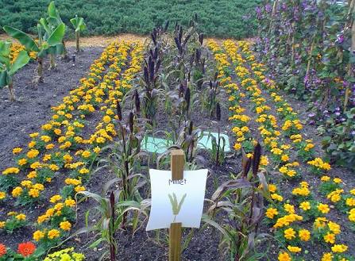
Fig 1. Marigold plant around the garden.

Pseudomonas:
Pseudomonas syringae is a rod shaped bacteria and gram negative with polar flagella, as a plant pathogen.It causes bacterial leaf spot in leafy greens.
Erwinia carotovora:
It is a rod shaped bacteria.It causes bacterial spot rot in leafy greens..
Xanthomonas citri:
It is a rod shaped bacteria.It causes citrus canker.
Methods: Earth worms Eisenia fetida were collected from river bank. The marigold wastes and vegetable wastes were collected from koyambedu market. The ideal temperature for the worm bin is 50 to 75 degrees Fahrenheit, or 12.8 to 23.9 degrees Celsius. verminsheds were prepared using plastic trays (15*10*10 cm) with lids. Put the spores in base of the tray and the lid to eliminate excess amount of water and for air flow. Shred up newspaper for bedding. Soak the bedding with water. Sprinkle soil in the plastic trays, which introduce artificial microorganisms. Gritty soil particles also aids the worms’ digestive process. Put an even layer of marigold waste on the top of the soil. Close the lid and wait for 10 days. Allow the materials to compost after a ten days introduced the worms into bin. Ten Earthworms were introduced into each tray.(fig.2)
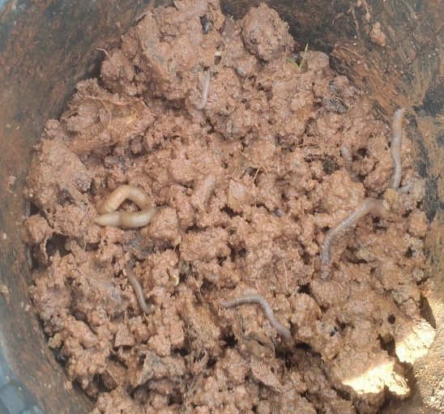
(Fig.2) Earthworms introduced into the tray.
The bedding was kept moisture throughout the experiment by regular watering. The experiment was terminated on the 60th day and the vermi compost produced by the worms are harvested.[7].The parameters such as pH, the nutrients were analyzed. Comparision between T1 & T2.
Anti microbial activity:
The antimicrobial activity of the sample was evaluated by agar well diffusion method[8]. Bacteria were grown in Muller Hinton broth to match the turbidity of 0.5 McFarland standards to be inoculated on Muller-Hinton agar. After inoculation, plates were dried for 15min, and the wells were punched using sterile cork borers.Once wells were formed, they were filled with 100 μL of compost extract and blanks . Commercially available gentamycin (10 μg) discs were used as a positive control in this study. Plates were incubated for 24 h at 37 °C to allow leaf extracts to diffuse through the agar media to form zones of inhibition. The diameters of the zone of inhibition for different leaf extracts against different bacteria were measured in millimetre for further analysis. An agar well (6 mm) showing no zone of inhibition was considered as no antimicrobial activity.
Results:
Vermicomposting is the Biodegradation system.[9] The parameters were analyzed for T1 & T2. T1 consist of vegetable wastes. Its gives a 60% NPK range. T2 consist of marigold wastes . Its gives a 75% NPK range. The number of earthworms and the weight of the earthworms are calculated.

.

S.NO | PARAMETERS | UNITS | T1 | T2 |  | SPECIFICATION
1 | Moisture | % | 18.93 | 18.23 |  | 15.0-25.0
2 | Colour | - | Black colour | Black colour |  | Dark brown to black
3 | Odour | - | Absence of foul odour | Absence of foul odour |  | Absence of foul odour
4 | Bulk density | G/cm2 | 0.82 | 0.79 |  | 0.7-0.9
5 | Total organic carbon | % | 18.6 | 21 |  | Minimum 16.0
6 | Total nitrogen(as N) | % | 1.5 | 1.9 |  | Minimum 0.5
7 | Total phosphorus(as P) | % | 1.2 | 1.1 |  | Minimum 0.5
8 | Total potash(as k2o) | % | 1.5 | 1.6 |  | Minimum 1.0
9 | C:N ratio | - | 18:1 | 18:1 |  | 20:1 or less
10 | pH | - | 6.54 | 6.78 |  | 6.5-7.5
11 | Conductivity | Dsm-1 | 3.8 | 2.7 |  | Not more than 4.0
Heavy metals
12 | Zinc as zn | Mg/kg | 242 |  | 264 | Max 1000.00
13 | Lead as pb | Mg/kg | 69.12 |  | 67.5 | Max 100.00
14 | Chromium as cr | Mg/kg | 21 |  | 20.79 | Max 50.00
15 | Copper as cu | Mg/kg | 155.43 |  | 153.76 | Max 300.00
. Table 1.Macro And micro nutrients of the vermicompost

Graph 1. NPK range between T₁and T₂ (T₂ has a high level of NPK).

Graph 2 . Range of heavy metals (T2 has a normal level of heavy metals than T1).

Table 3.Growth range of Earthworms
Duration | No Of Earthworms |  | Weight Of Earthworms (Gm)
 | T1 | T2 | T1 | T2
0 day | 10 | 10 | 0.9-11 | 0.9-11
After 10 days | 10 | 10 | 1.1 | 0.9
After 40 days | 15 | 14 | 4.6 | 5.5
After 60 days | 35 | 37 | 16.5 | 18.2
Graph 3 .Growth range of Earthworms (number and weight of the earthworms were gradually increased in T2).
.

Growth of spinach:

Fig.3.Growth of spinach without any disease using marigold fertilizer

Antimicrobial activity:
Zone of inhibition in mm
S.no | Culture | Trial-1, mm | Trial-2 , mm | Trial-3, mm
1 | Pseudomonas syringae | 24 | 20 | 21
2 | Erwinia carotovora | 24 | 20 | 20
3 | Xanthomonas citri | 1 | 2 | 1
Table4. zone of inhibition formed by marigold fertilizer on different test bacteria.

Graph 4.zone of inhibition formed by marigold fertilizer on different test bacteria.

Discussion :
NPK range of the two vermicomposts are equally same. Marigold compost has a high NPK range when compared vegetable compost. We have planted a spinach in one pot using a marigold compost and another pot using vegetable compost. Spinach is one of the vegetable which comes under “Dirty Dozen”,that proves, spinach can’t grow without any disease absence of using any pesticide. In present study, spinach grows well without any disease using marigold fertilizer.[10] That shows marigold may be having a pesticide activity.we analysed the antimicrobial activity of the marigold to the plant pathogenic bacteria. That shows the antimicrobial activity against plant pathogenic bacteria.
Conclusion:
This study offers a simple and economical alternative through vermicomposting to resolve the management of marigold waste[10] From this project we got a good fertilizer through vermicomposting as well as good pesticide .

REFERENCES:

- Kaviraj, Sharma S. (2003) Municipal solid waste management through vermicomposting employing exotic and local species of earthworms. Bioresource Technology 90, 169-173.
- Kale R.D, Vermiculture Scope for the new biotechnology , in Earthworm Resources and Vermiculture ( Zoological Survey of India,Cacutta) 1993, 105-108
- Lehman,P.S.1979. Factors influencing nematodes controls with marigold. Florida Dept. of Agriculture conservation service,Nematology Service ,circular no.50. April 1979.
- Mcclure susan 1994. Companion planting .rodale press.ISBN 0-87596-616-0.

- Dumenil G, Chemli R, Balansard C, Guiraud H, Lallemand M (1980). Evaluation of antibacterial properties of marigold flowers (Calendula officinalis L.) and mother homeopathic tinctures of C.officinalis and C. arvensis L., Annales pharmaceutiques francaises 38(6): 493-499.

- Radioza SA, Lurchak LD (2007). Antimicrobial activity of Calendula L. plants, Mikrobiol., 69(5): 21-25.
- Aalok,A ; Tripathi,A.K.Sonl,P.(2008) vermicomposting method.
- Bauer AW, Kirby WMM, Sherris JC, Turck M (1966). Antibiotic susceptibility testing by a standardized single disk method, Am. J.Clin. Pathol., 45(4): 493-496.
- Bhawalkar,U.S,Vermiculture Biotechnology for LEISA , seminar on low external input agriculture,Amsterdam,Netherlands,1991.
- B.T.Hunter, ”Gardening without poisons” ,2nd ed., Berkley; Newyork,1964;P.46.(Google Scholar)

